

ADAS Horizon Sensor Requirements

Revision 0.93

June 2 2014

Change Control

Revision | Revision Date | Author / Modifier | Description / Modifications | Sections Affected
0.5 | 7 May 2010 | Aking6 | Initial Pre-release for supplier review. | All
0.6 | 15 Oct 2010 | Aking6 | Updated to reflect implementation within SYNC | All
0.7 | 20 Jan 2011 | Aking6 | Updated to sync with DVMs, revised architecture to reflect interaction with Navigation function, revised data referenced, added verbosity level requirement, updated referenced documents. | All
0.8 | April 2011 | Jrequejo | Adding section on calibration and ADASIS configuration | 11.7, 11.8
0.9 | 31 Jul 2011 | Aking6 | Added statement regarding ADASIS v2 Mini; updated calibration parameters table, changed names to match Ford CGEA naming conventions, and added resolution and default values. Also modified Ford specific Profile message definitions. Changed section 11.5 to reflect Map Data requirements. | 11.5, 11.6, 11.8
0.92 | 21 Sept 2011 | Aking6 | Moved "Additional ADASIS Configuration" information into the Data Dictionary Clarification Document. Reorgnaized section 11.6, split into "ADASIS v2" and "CAN Output Config" sections. Added Profile Long configuration param. Revised Navigation routing use case. | 11.1, 11.6, 11.7, 11.8
0.93 | 12 Dec 2012 | Aking6 | Treatment of roundabouts and complex intersections in MPP calculation clarified. | 11.3.2
0.94 | 1 April 2014 | DHERMAN | Replaced GPS with GNSS  Made Sync Gen3 Changes to spec  Added Stub Expansions  Added Probe Data Profile  Updated core document references  Update Verbosity level definition
Table of Contents
1 Preface 5
2 References 6
3 Glossary 7
4 Introduction 8
5 Markets 8
6 Hardware Design Requirements 8
7 Software / Hardware Architecture 8
7.1 SD Card 8
7.2 APIM Module 8
7.3 Control Signals and Data 10
7.4 Off-Board Data Import 10
8 Diagnostics 10
9 Electrical System Integration (Not Applicable) 10
10 Mechanical systems integration (Not Applicable) 10
11 ADAS Horizon Functional Requirements 10
11.1 ADAS Horizon Use Cases 10
11.1.1 Use Case Descriptions 10
11.1.2 General Use Case Requirements 15
Path Identification requirements 15
Position requirements 15
11.2 ADAS Map Database 16
11.2.1 Supported Countries 16
11.2.2 Data clusters 17
11.2.3 Data cluster memory 18
11.2.4 Map Update 18
11.2.5 ADAS Map Availability 18
11.3 Most Probable Path (MPP) Determination 18
11.3.1 Path length 18
11.3.2 MPP Method 19
11.3.2.1 Standard MPP 19
11.3.2.2 Turn Signal Biasing 19
11.3.2.3 Pre-planned Routing 19
11.3.2.4 Other Path Biasing Methods 19
11.4 ADAS Horizon Data extraction 19
11.4.1 Horizon Provider Mode 19
11.4.2 In- and Out-bound Links 19
11.4.3 Attributes Extracted 19
11.5 ADAS Horizon Data Output 20
11.5.1 Output Data 20
11.5.1.1 Intersection Junctions (Stubs) 20
11.5.1.2 Road Geometry 20
11.5.1.3 Road Information 20
11.5.2 Verbosity Level 21
11.6 ADASIS v2 Format and CAN Output 21
11.6.1 ADASIS v2 21
11.6.2 Current Ford ADAS Horizon protocol 22
11.6.3 Customization of ADASIS v2 22
11.6.3.1 Alternative Speed Limits 22
11.6.3.2 Effective Speed Limit 23
11.6.4 Position Message Updates 23
11.6.5 Segment, Stub, Profile Message Updates 23
11.6.6 MPP Change Data Repopulation Time 23
12 HMI 23

List of Figures

Figure 1. ADAS Horizon Software Architecture 9
Figure 2. Use Case 1: Vehicle Start-up. 10
Figure 3. Use Case 2: Normal Operation 11
Figure 4. Use Case 3: GNSS Lost 12
Figure 5. Use Case 4. Navigation Routing 13
Figure 6. Use Case 5: Entering Unmapped Area 14

Preface
This Document defines the Advanced Driver Assist System (ADAS) Horizon Sensor software Application.

The document serves the following objectives:

A. Defines the specific requirements for the ADAS Horizon application.
B. It is considered the central source of unique customer requirements placed on this subsystem.
C. Places quantitative design requirements on design activities.
D. It is used as a source for subsystem validation activities.

It is not the intent within the confines of this document to cover items that are intrinsically covered in other component level specifications (ES) or sub-subsystem specifications (SPSS). Revision to this document will be made based on collaboration between Ford and the navigation supplier. Only then are they considered as accepted for use in this application.

The target audience of this document includes.
- Core engineering / supplier responsible for developing the ADAS Horizon sensor and its subsystems.
- Supplier responsible for providing ADAS map data.
- Core engineering responsible for developing customer functions that use the ADAS Horizon data.

References

Section | Document | Revision
Function | Embedded Navigation Application Engineering Specification (Nav App ES 2.4 Released.doc) | V2.4, Sept 21, 2009
Function | ADASIS v2 Protocol (200v2.0.3-D2.2-ADASIS_v2_Specification.0pdf) | Version 2.0.3.0 December 2013
Function | ADAS Horizon Data Dictionary (EH data dictionary v7 1Apr2014.xls) | Version 7 April 1, 2014
Algorithm | Electronic Horizon Most Probable Path Algorithm Description Document (EH MPP algorithm description.doc) | V0.6, 1 Apr 2014
Function | ADASIS v2.0 Data Dictionary Clarification  (ADASISv2_Data_Dictionary_Clarification.docx) | V0.99, April 1, 2014
Function | Electronic Horizon APIM SPSS, ver 1_0 May 31 2013.pdf | ver 1_0 May 31 2013

All of the requirements contained in all of the above external references must be met.

The most recent released version of each document shall be used at all times.

Glossary

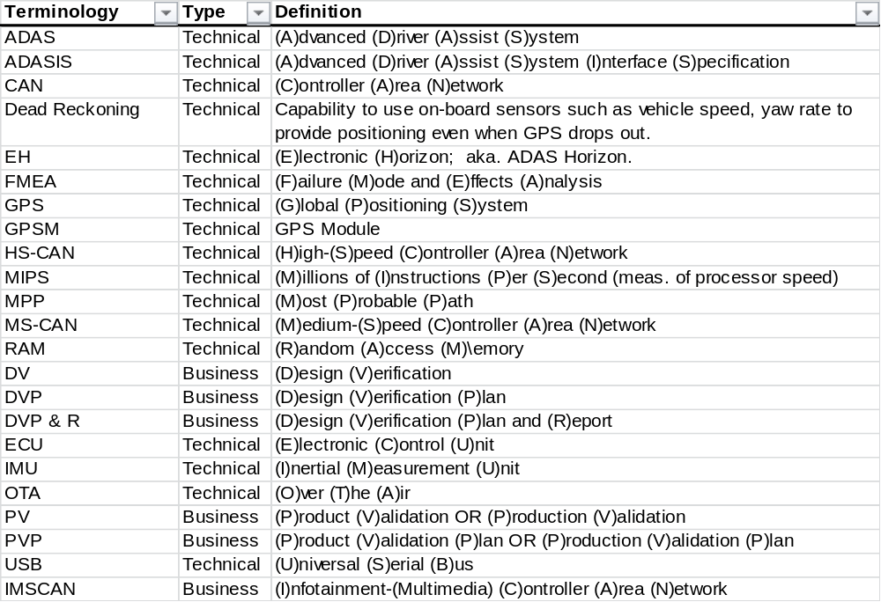

Introduction
This Document defines the Advanced Driver Assist System (ADAS) Horizon Provider.

The ADAS Horizon Provider is a sensor that provides information about upcoming road attributes based on map data. The ADAS Horizon Provider consists of ADAS Map data and ADAS Horizon application software. The ADAS map data will be included with the Navigation map data in the SD Card. The application software of the provider is to be integrated as part of the Embedded Navigation application in the APIM. Refer to the Navigation and APIM engineering specifications for related information.

The ADAS Horizon Provider data will be used in association with other actuators, modules, and systems in the vehicle

The scope of this document is to:
- Define System boundaries
- Define Use Cases
- Define Data requirements
- Define generic Most Probable Path (MPP) requirements
- Define output protocols

All software development and validation shall be conducted in collaboration between the ADAS Horizon supplier, the Navigation Supplier, APIM System Integrator, and Ford Motor Company.

The supplier is required to satisfy all the requirements of this specification and other referenced documents and specifications where applicable.

Markets
The ADAS Horizon Provider is to be capable of operation across the markets identified in the section 11.2.1.

Where achievable, a common solution for each country variant is required. The ADAS Horizon supplier shall achieve market differentiation via end of line programming or market-specific application software and map database content.

Hardware Design Requirements
The ADAS Horizon supplier shall provide their minimum hardware resource requirements and design constraints (flash memory, RAM, graphics controller, MIPS processing speed, etc.) to meet the functional requirements defined in this document. The supplier shall also provide a proposed functional allocation.

The final hardware design shall be determined by the APIM hardware design team in collaboration with the Navigation supplier and the APIM System Integrator

Software / Hardware Architecture
Reference igure 1. ADAS Horizon Software Architecture.

Data Store
The compiled ADAS Map Data (A) will be contained within a relevant datastore (SD Card or internal EMMC/SSD) which contains the Navigation map data among other SYNC required data. The Navigation supplier shall compile the ADAS Map Data long with the Navigation map data for delivery as a package.

APIM Module
The ADAS Horizon application software shall be an embedded software application within the APIM module. In this version, the ADAS Horizon application shall exist as an extension of the existing SYNC-based Navigation application.

All software development and validation shall be conducted in collaboration among the ADAS Horizon supplier, the APIM system integrator, and Ford Motor Company.

The ADAS Horizon application software supplier shall provide their minimum software resource requirements (e.g. data buffer sizes) and design constraints to meet the functional requirements defined in this document.

The ADAS Horizon application shall include the following software components, as identified in the software diagram below: Most Probable Path Determination (C), Map Data Extraction (Along MPP) (D), and Data Packaging into ADASISv2 format (E).

It is expected that the Map Matching and Dead Reckoning (B1) and Navigation Routing (B2) functions will be contained within the existing Navigation application; the dead reckoned, map matched position data and navigation route data generated by these functions, respectively, will then be used as an input to the ADAS Horizon application.

Additionally, the CAN Message Block of the APIM module shall also include the component, (F) ADASISv2 CAN Messages Generated.

figure 1. ADAS Horizon Software Architecture

Control Signals and Data
The APIM Data Manager shall manage the exchange of control signals and data between the ADAS Horizon Provider and the infotainment and vehicle network.

The CAN messages shall be generated according to the referenced "Electronic Horizon Server SPSS" document, which is based upon the ADASISv2 specification.

Off-Board Data Import
Not applicable for this release.

Diagnostics
TBD

Electrical System Integration (Not Applicable)
Not applicable for the ADAS Horizon embedded application.

Mechanical systems integration (Not Applicable)
Not applicable for the ADAS Horizon embedded application.

ADAS Horizon Functional Requirements
The Map-enabled Advanced Driver Assist System (ADAS) Horizon Provider is intended to create a "local" map around the host vehicle, along a path that will most probabilistically be driven, which provides upcoming road attributes of interest such as traffic signs, curves, road slopes, lane types, etc. to ADAS customer functions. The ADAS Horizon application uses the vehicle positioning information from the GNSS Module (GNSS M) and inertial state information (yaw, acceleration, vehicle speed) to locate the host vehicle on an ADAS map, identify the "most probable path" (MPP) the driver will take, extract upcoming road attributes along the MPP, and package the attributes for output onto CAN using the globally agreed standard ADASIS v2 protocol.

ADAS Horizon Use Cases

Use Case Descriptions
In general, the ADAS Horizon Provider shall follow the usage guidelines in Section 5 of the ADASIS V2 (2.0.0) specification.

Use Case 1: System Start-up
Upon ignition or accessory or run/start state, the ADAS Horizon Provider waits for GNSS to converge, and then attempts to obtain a match position on the map and direction of travel. Once achieved, MPP is determined and Position, Segment, Stub, Mata-data and Profile Short messages are constructed as documented in the ADASIS V2 (2.0.0) specification. The messages are sent in rapid bursts to populate the ADAS Horizon out to the maximum length specified as quickly as possible.
If there is no map matched position, send Position message with Path_index value defined by Table 7 in the ADASIS V2 specification.
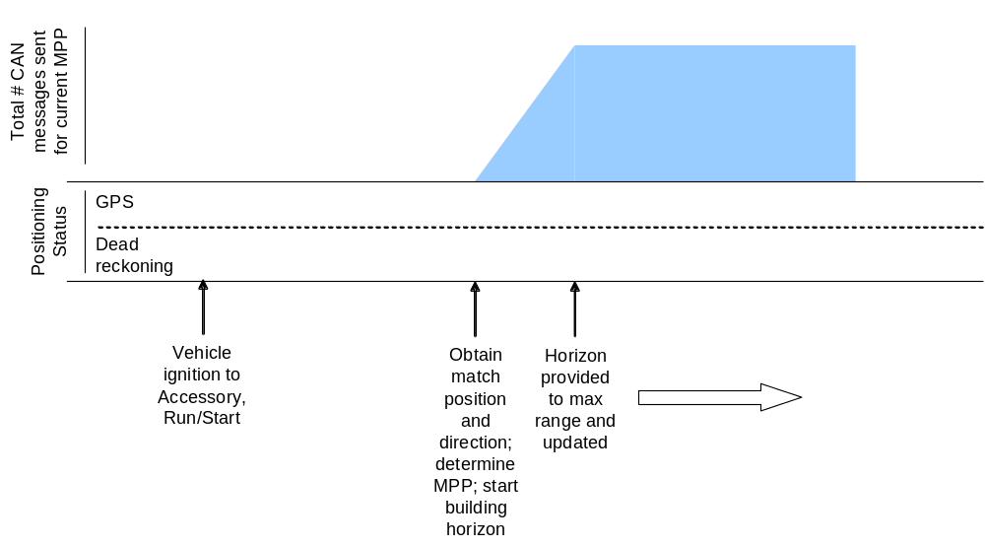
Figure 2. Use Case 1: Vehicle Start-up.

Use Case 2: Normal Operation
Once position is confirmed, the ADAS Horizon Provider first transmits all the desired road attributes up to the specified horizon distance (e.g. 2000m) based on an assumed MPP. As the host vehicle travels along this path, new attributes or changes in attributes that enter into the horizon distance will be transmitted once in the form of new Segment, Stub, or Profile messages by the ADAS Horizon Provider. If there exists no changes in attributes over a certain (TBD) distance, the current Segment message shall be resent.If stub expansion is enabled, reuse applicable subpath as required

If the driver diverts from the current MPP (e.g. host vehicle turns onto a different road, usage of turn signal), a new MPP with a new path ID is calculated and the ADAS Horizon application and repopulate the entire horizon with new road attribute data based on the new assumed MPP.

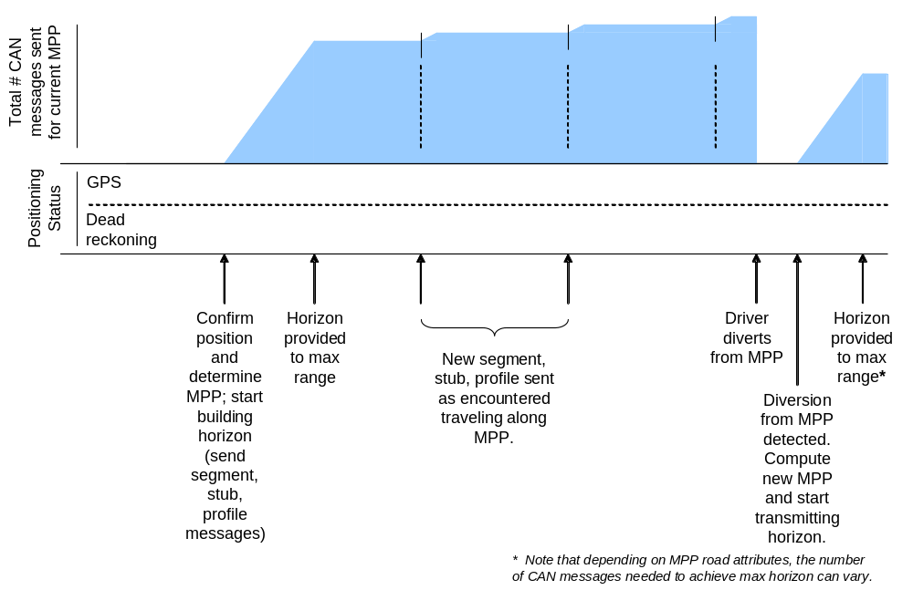
Figure 3. Use Case 2: Normal Operation

Use Case 3: GNSS Lost
If GNSS signaling is lost (due to urban canyons, poor weather, GNSS "dead zone", etc), the system shall be able to continue updating vehicle position by use of Dead Reckoning. Once GNSS signals are reacquired, normal operation will continue.
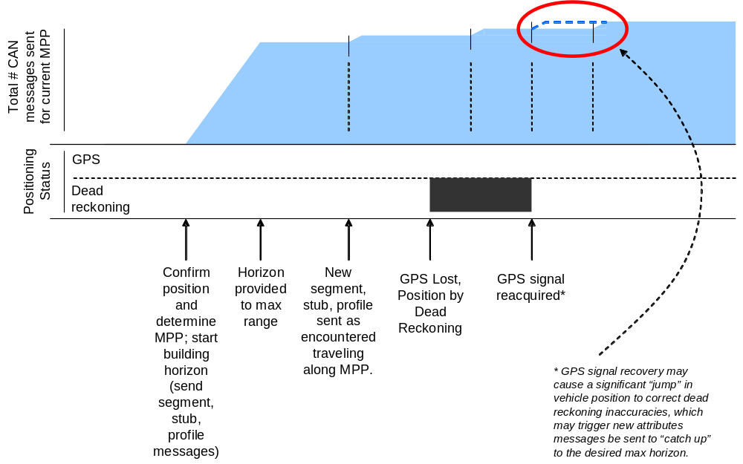
Figure 4. Use Case 3: GNSS Lost

Use Case 4: System Start-up – Navigation Routing
If there exists a Navigation system in the vehicle and a Navigation route is set, the predetermined route shall be provided to the ADAS Horizon Provider and used as a weight for the MPP calculation. If the driver diverts from the MPP AND the set navigation route, the ADAS Horizon Provider shall calculate a new MPP while the Navigation system is still rerouting, and use that new MPP to immediately transmit a new horizon. Once the Navigation system completes the rerouting, this new route shall be provided to the ADAS Horizon Provider to reset the MPP again. The Provider will then reset and send out the new horizon. Note that ADAS Horizon is only provided at maximum to the Navigation destination. If the active route destination is reached, and the driver chooses to keep driving, the behavior shall then follow Use Case 2

Note: A strategy needs to be developed to handle the potential conflict between the Navigation route and a non-route MPP (should driver purposefully divert from route). See the Preferred_Route_Segment_Transition_factor variable in Section 6, Computing Horizon Weights, in the "Implementing Electronic Horizon" white paper.

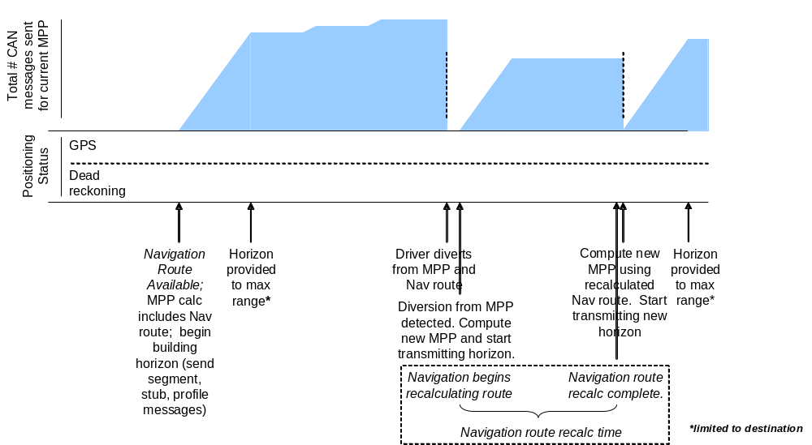

Figure 5. Use Case 4. Navigation Routing

Use Case 5: Entering Unmapped Area
If the vehicle drives into an area where there exists no map data, then the map match position (as thus MPP) will no longer be valid. The ADAS Horizon Provider will send a Position message with Path_index value defined by Table 7 in the ADASIS V2 specification. Once a valid match position and direction is reacquired, a new MPP will be determined and a new horizon will be provided.
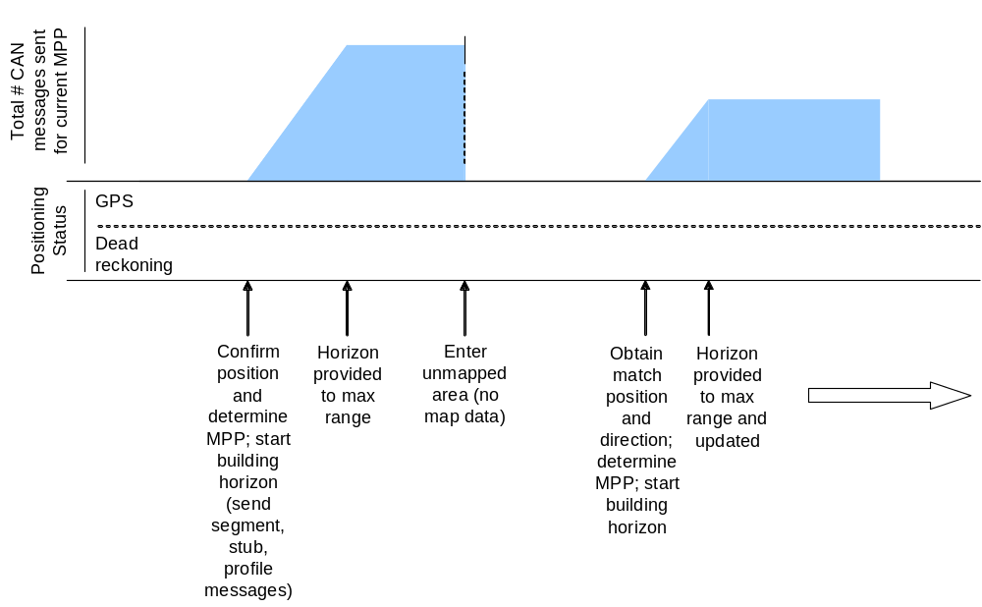
Figure 6. Use Case 5: Entering Unmapped Area

General Use Case Requirements

The behavior described by the previous five use-cases implies the following requirements:

Path Identification requirements
Situations where the vehicle leaves the most probable path must be detected properly.

PI-1 Losing vehicle positioning must lead to lack of MPP. This means that the positioning engine cannot determine where the vehicle is located. This could be because it is either driving off-road (i.e. parking area), poor GNSS reception for long periods of time, etc. In such situations the electronic horizon must report that position is unknown, and there is no MPP available.
PI-2 Regaining map matching generates a new MPP, and that applications are able to recognize it. If vehicle is coming from a situation where position is unknown and MPP is not available, regaining positioning must lead to a new MPP. This scenario could be reproduced by driving on an unmapped parking lot and entering a main road. After vehicle starts driving on a mapped road again, positioning engine must be able to deliver a vehicle location within a specified time threshold. After vehicle is matched to the road and position is available, electronic horizon tree must become available along with its MPP. The ID of the new MPP must be different from the one before the map matching was lost.

PI-3 A new MPP must be recognizable by consuming applications. This means that performing a turn not predicted by the MPP must generate a new horizon. The ID of the newly computed MPP must be different from the one before the transition.

Position requirements
Verify correctness of the vehicle positioning engine, by testing scenarios that could lead to map matching issues and a degraded or absent GNSS signal.

LGNSS -1: that driving in a tunnel does not lead to loss of positioning or MPP. Despite lack of GNSS signal, vehicle position must still be available throughout the tunnel section. Vehicle can be seen travelling forward inside the tunnel, in accordance to the speed reported by the vehicle instrumentation.
LGNSS -2: entering an underpass does not lead to loss of positioning or MPP. Despite temporary lack of GNSS signal, vehicle position must be continuously available. Vehicle can be seen travelling ahead inside the underpass, in accordance to the speed reported by the vehicle instrumentation.
LGNSS -3: driving inside urban canyons does not lead to loss of positioning or MPP. Despite temporary poor GNSS constellation and therefore GNSS -based positioning, vehicle position must still be available. Vehicle can be seen travelling ahead or taking turns inside the urban canyon. Occasional jumps in vehicle positioning might be acceptable.
Possible testing method: perform procedure described above by driving through a city with high buildings on both sides of the road and observing the quality of the reported positioning.
LGNSS -4: driving inside forests does not lead to loss of positioning or MPP. Despite temporary poor GNSS constellation and therefore GNSS -based positioning, vehicle position must still be available. Vehicle can be seen travelling forward. Occasional jumps in vehicle positioning might be acceptable.

LP-1: vehicle positioning must be lost when driving in an unmapped area, such as an off-road situation, driving in a parking lot, etc. even if GNSS reception is good. Closest road present in the map is must be at least 15 meters away from actual vehicle location. Electronic horizon must report that matched position is unknown, and there is no MPP available. Exact GNSS location might be reported if necessary.

LP-2: positioning is not lost when driving along a mapped road and in the presence of good GNSS signal.

ADAS Map Database
The ADAS map database shall be included in the SD Card where the Navigation map data resides, and be accessible to the ADAS Horizon application. The Navigation supplier shall compile both the ADAS and Navigation map data together in a package.

Note: These ADAS Horizon Map Database requirements are for the first generation of ADAS Horizon function. Subsequent generations may include additional data needs.

Supported Countries
ADAS Map data shall be provided for the following countries/territoriesregionI. , if available. For client applications, supported markets should be reviewed with the Navigation team prior to any implementation.
- North America
  - USA
  - Puerto Rico
  - US Virgin Islands
  - Canada
  - Mexico
- Western Europe
  - Austria
  - Belgium
  - Canary Inlands
  - Denmark
  - Finland
  - France
  - Germany
  - Ireland
  - Italy
  - Liechtenstein
  - Luxemburg
  - Monaco
  - Norway
  - Portugal
  - San Marino
  - Spain
  - Sweden
  - Switzerland
  - The Netherlands
  - United Kingdom
  - Vatican
- Eastern Europe
  - Czech Republic
  - Slovakia
  - Poland
  - Hungary
  - Slovenia
  - Estonia
  - Latvia
  - Lithuania
  - Croatia
  - Romania
  - Bulgaria
  - Serbia and Montenegro
  - Bosnia/Herzegovina
  - Albania
  - Macedonia
  - Greece
  - Turkey
  - Russia
- South America
  - Brazil
  - Argentina
  - Chile
- Pacific
  - Australia
  - New Zealand
- Middle East
  - Bahrain
  - Kuwait
  - Oman
  - Qatar
  - Saudi Arabia
  - United Arab Emirates
  - Jordan
- Asia
  - Japan
  - China
  - Korea
  - Taiwan
  - Malaysia
  - Singapore
  - India
- Africa
  - South Africa

Data clusters
The strategy to partition the data clusters shall be jointly developed between Ford Motor Company and the navigation supplier. The supported data clusters are listed below:
- Individual clusters:
  - Complete Europe
  - Western Europe
  - Eastern Europe
  - North America
  - Pacific (supported after initial release based on program demands)
  - Middle East (supported after initial release based on program demands)
  - South America
  - Asia (China market shall be supported at initial launch and other will be supported on based on program demands)
  - Africa (supported after initial release based on program demands)

Data cluster memory
The supplier shall provide the required memory size sufficient to account for the largest data cluster, as well as projected growth over 10 years as map data gets updated.

Map Update
The supplier shall provide capability to update the ADAS map data on regular intervals (at the same cadence as embedded navigation base map updates at a minimum) to ensure the latest map info is available for ADAS Customer Functions that use the ADAS Horizon. Incremental updates shall be made available if applicable and if frameworks (licensing, IT backend and business case) for delivery are in place, where only the portions of the map that have changed will get updated to minimize necessary bandwidth for potential onboard download.

ADAS Map Availability
TBD.

Most Probable Path (MPP) Determination
The ADAS horizon and its MPP must be built in accordance to user-defined parameters such as length, minimum distance, and minimum expansion probability. In addition, they verify that the horizon remains consistent as the vehicle transitions from one link to the next. The method to implement MPP is described in the referenced document "EH MPP algorithm description”

The characteristics described in this section directly imply the following requirements:

EHCT-1: MPP is always expanded to at least minimum depth, regardless of link probabilities. This means that unless the last node along MPP has no possible successors (i.e. dead-end road), its length must be always longer than the minimum specified depth.
EHCT-2: assuming that the length of MPP is greater than the minimum depth, MPP shall not expand links with probabilities below the minimum specified threshold.
EHCT-3: assuming that the vehicle is matched to a road and most probable path exists, the distance from vehicle position to beginning of second to last link along MPP must be either less than the minimum horizon depth, or its probability must be higher than the minimum specified threshold. Either of these two conditions would allow expanding from the second to last link to the last link.
EHCT-4: assuming that the vehicle is matched to a road, most probable path exists and probability of last link is higher than minimum specified threshold, then the distance from vehicle position to end of last link must be greater than maximum horizon length.
EHCT-5: assuming that the vehicle is matched to a road and most probable path exists, the predictor engine must be able to compute the probability of transitioning from each incoming link to its respective successors. The sum of the probabilities of all successors from an incoming link must be equal to that of the incoming link.

LT-1: assuming that the vehicle is matched to a road and most probable path exists, transitioning from the root link to the next link along the most probable path must be consistent. With the exception of the root link left behind and all ex-siblings of the new root, the old electronic horizon tree must be contained in the new horizon tree. The new tree must be normalized by dividing the probability of each link by the probability of the new root.
LT-2: assuming that the vehicle is matched to a road and most probable path exists, transitioning from the root link to a link different from the next link along the most probable path must be consistent. Such a transition must trigger the generation of a new most probable path.

Path length
The ADAS Horizon application shall estimate the MPP to a horizon depth that varies vary according to vehicle speed, and essentially allow the minimum horizon to be based on a "min time ahead". This is set by the configuration variable "Horizon Depth Scale Factor" which is definable by Ford and located in a configuration file read at startup. The methodology for determining the variable path length is described in the referenced document "Dynamic Computation of Electronic Horizon Length".

MPP Method

Standard MPP
The MPP predictor should compute the MPP for a specified length based on a static predictor using Map attributes such as functional class, turn angle, road type, speed limits, etc. The supplier shall provide a specification describing the exact implementation.

Turn Signal Biasing
The MPP predictor shall also use input from turn signal indicators to predict the MPP. This is if the data is available on the can bus (Sync Gen 2/3 to not support)

Pre-planned Routing
The ADAS Horizon application shall accept a pre-planned route from the Navigation application and use this to significantly bias the MPP. The application shall be able to send the ADAS Horizon map of this entire route on request of an external function.

Treatment of Complex Intersections and Roundabouts
Complex Intersections and Roundabouts should be considered cost neutral in MPP calculation. Only the spokes of these intersection features should be considered in the calculation.

Other Path Biasing Methods
The ADAS Horizon application shall be capable of accepting other Ford-developed path biasing algorithms as an addition to the existing MPP method, or accept a new Ford-developed MPP method as a replacement.

ADAS Horizon Data extraction

Horizon Provider Mode
The ADAS Horizon shall use the Most-Probable Path with Stubs mode for providing the horizon (Sync Gen2). See the ADASISv2 specification for further details. Sync Gen 3 will add stub expansion for non-MPP stubs (see EH MPP algorithm description)
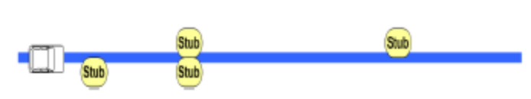

In- and Out-bound Links
The ADAS Horizon application shall output stub information for both in-bound and out-bound links.

Attributes Extracted
At a minimum, the attributes described in the referenced document "ADAS Horizon Data Dictionary" should be extracted from the ADAS Horizon map. Note that attribute availability can be varied for different route types.

Specific notes:

Curvature Extraction
Curvature shall be extracted and delivered every TBD meters (to be agreed with supplier).

Slope Extraction
Slope shall be extracted and delivered every TBD meters (to be agreed with supplier).

Effective Speed Limit
If on a certain road the speed limit varies according to time, the ADAS Horizon shall extract the effective speed limit which is valid for the current time.

ADAS Horizon Provider Map Data

Intersection Junctions (Stubs)
The ADAS map shall include the following information about intersection junctions (stubs).

Intersection Position
The ADAS map shall contain the position of intersections, defined at the midpoint of the intersection.

Angles of Intersecting Roads
The ADAS map shall contain the Angle of an intersecting road relative to current road, or sufficient information to calculate the angle.

Road Geometry

Curvature
The ADAS map shall contain the curvature of roads in equation format, with radius accuracy within ±5%. Supplier shall provide specifications for the format.

Slope
The ADAS map shall contain the slope of roads (road grade) in shape point format, with accuracy within ±1%.

Link heading
The ADAS map shall contain heading information for road links.

Road Information

Route Type
The ADAS map shall contain the "route type" of the roads, including beginning and end points, defined per the ADASIS v2 protocol.

Road Type (Form of Way)
The ADAS map shall contain the road type (or form of way) of the roads, including beginning and end points, defined per the ADASIS v2 protocol.

Speed Limits
The ADAS map shall contain Speed Limits of the roads in units of 5 km/h or 5 mi/h, including beginning and end points with the Speed Limit Type defined per the ADASIS v2 protocol..

The ADAS map shall include alternative speed limits if applicable (e.g. vary by time of day, weather, etc.),

Lane count in travel direction
The ADAS map shall contain the number of lanes in the travel direction of the roads, including beginning and end points.

Tunnel Identification
The ADAS map shall contain placement of tunnels, including identification of tunnel entrance / exit points.

Bridge Identification
The ADAS map shall contain placement of bridges.

Bridge Deck Type
The ADAS map shall contain information about the bridge deck type, including metal grate, asphalt, concrete, etc.

Divided Road
The ADAS map shall contain information about divided highways structures of the roads.

Extended lanes (Acceleration and deceleration lanes)
The ADAS map shall contain Extended lane information about the road, identifying where acceleration and deceleration lanes begin and end.

Speed Limit Signs
The ADAS map shall contain the longitudinal position (along the path) and value of speed limit signs on the roads.

Alternative Speed Limits
The ADAS map shall contain alternative speed limits values as well, such as those that vary based on time of day, weather conditions, etc.

Variable Speed Limit Sign Position
The ADAS map shall contain the location and lane placement of variable speed limit signs, defined per the ADASIS v2 protocol.

Traffic Lights
The ADAS map shall contain longitudinal position (along the path) of traffic lights.

Stop Signs
The ADAS map shall contain the longitudinal position (along the path) of stop signs.

Yield Signs
The ADAS map shall contain the longitudinal position (along the path) of yield signs.

No Passing Zone
The ADAS map shall contain the longitudinal position (along the path) of "no-passing" zones, including beginning and end points.

Urban Area
The ADAS map shall contain information about where an urban area begins and ends based on signage.

Left and Right hand traffic
The ADAS map shall contain information on whether the road has right or left hand traffic.

ADASIS v2 Format

ADASIS v2 Output
The ADAS Horizon Provider shall use the ADASIS v2 protocol for packing data for output onto CAN.

ADASIS v2 Configuration
Ford-specific configuration detail of the standard ADASIS message types is detailed in the "ADAS Horizon Data Dictionary" and "ADASIS v2.0 Data Dictionary Clarification" specifications.

ADASIS v2 Mini
The ADAS Horizon Provider shall also support the ADASIS v2 Mini protocol, which only sends a SEGMENT message with data pertaining to the current segment on which the host vehicle is driving. The Path Index value should be 4. Other messages (e.g. POSITION, PROFILE) are not used.

Customization of ADASIS v2: Profile Short
Some attribute outputs are not defined in the standard message types of the base ADASIS v2 protocol, and shall be created jointly with Ford using custom "system specific" ADASIS v2 "Profile Short" message types.

Detailed specification of ADASIS Profile Short Message structure can be found in the ADASISv2 specification. This message contains two 10-bit Profile Spots that are up to 1023 meters away. Interpretation of spot values as well as profile interpolation between spot values depends on the actual Profile Type. This Profile Type contains some pre-defined values, such as
- Curvature
- Route Numbers
- Slope
- Road accessibility
- Road condition
- Variable Speed Sign Position
- Heading Change

but as well reserved bits for standard and system specific types. Since the bits "Reserved for standard types" are spare bits for future ADASIS versions, the 16 bits "Reserved for system specific types" can be defined proprietarily according to Ford's requirements. If Ford has already developed an existing encoding structure for these attribute outputs, then the supplier shall use the existing Ford encoding.

Ford "system specific" profile types are detailed below, and are also found in the "ADAS Horizon Data Dictionary" document.

Implicit Speed Limits
Implicit Speed Limit information shall be identified using Profile Short Type 16.

The Profile "Value 0" and "Value 1" fields shall be encoded such that Bits 0-2 will be used as information about first additional speed limit type, bits 3-7 will indicate the implicit speed limit itself. The speed limit values are specified the same way than the values for effective speed limit in segment message. The signal will in total have a length of 10 bit according to ProfileShort_Value0 and ProfileShort_Value1 ADASISv2 specification. Specific encoding is below.

Bits 0-2: Implicit Speed Limit Type
0x0: Implicit - Highway
0x1: Implicit - Rural
0x2: Implicit - Urban Highway
0x3: Implicit - Urban
0x7 : N/A

Bits 3-7: Effective Speed Limit
0x00: Unknown
0x01: ≤ 5 km/h [mph]
0x02: 7 km/h [mph]
0x03: 10 km/h [mph]
0x04: 15 km/h [mph]
0x05: 20 km/h [mph]
0x06: 25 km/h [mph]
0x07: 30 km/h [mph]
0x08: 35 km/h [mph]
0x09: 40 km/h [mph]
0x0A: 45 km/h [mph]
0x0B: 50 km/h [mph]
0x0C: 55 km/h [mph]
0x0D: 60 km/h [mph]
0x0E: 65 km/h [mph]
0x0F: 70 km/h [mph]
0x10: 75 km/h [mph]
0x11: 80 km/h [mph]
0x12: 85 km/h [mph]
0x13: 90 km/h [mph]
0x14: 95 km/h [mph]
0x15: 100 km/h [mph]
0x16: 105 km/h [mph]
0x17: 110 km/h [mph]
0x18: 115 km/h [mph]
0x19: 120 km/h [mph]
0x1A: 130 km/h [mph]
0x1B: 140 km/h [mph]
0x1C: 150 km/h [mph]
0x1D: 160 km/h [mph]
0x1E: Unlimited
0x1F: N/A

1023 = unknown or N/A

Posted Speed Limits
Posted Speed Limit information shall be identified using Profile Short Type 17.

The Profile "Value 0" and "Value 1" fields shall be encoded such that Bits 0-4 will indicate the posted speed limit. The speed limit value is specified the same way as the values for effective speed limit in segment message. The signal will in total have a length of 10 bit according to ADAS_ProfShort_Value1 ADASISv2 specification.

Bits 0-4: Posted Speed Limit
0x00: Unknown
0x01: ≤ 5 km/h [mph]
0x02: 7 km/h [mph]
0x03: 10 km/h [mph]
0x04: 15 km/h [mph]
0x05: 20 km/h [mph]
0x06: 25 km/h [mph]
0x07: 30 km/h [mph]
0x08: 35 km/h [mph]
0x09: 40 km/h [mph]
0x0A: 45 km/h [mph]
0x0B: 50 km/h [mph]
0x0C: 55 km/h [mph]
0x0D: 60 km/h [mph]
0x0E: 65 km/h [mph]
0x0F: 70 km/h [mph]
0x10: 75 km/h [mph]
0x11: 80 km/h [mph]
0x12: 85 km/h [mph]
0x13: 90 km/h [mph]
0x14: 95 km/h [mph]
0x15: 100 km/h [mph]
0x16: 105 km/h [mph]
0x17: 110 km/h [mph]
0x18: 115 km/h [mph]
0x19: 120 km/h [mph]
0x1A: 130 km/h [mph]
0x1B: 140 km/h [mph]
0x1C: 150 km/h [mph]
0x1D: 160 km/h [mph]
0x1E: Unlimited
0x1F: N/A

1023 = unknown or N/A

Conditional Speed Limits
Condition Speed Limit information shall be identified using Profile Short Types 18, 19, and 20. Type 18 is known as "Conditional Speed Limit 1", Type 19 is "Conditional Speed Limit 2", and Type 20 is "Conditional Speed Limit 3".

The Profile "Value 0" and "Value 1" fields shall be encoded such that Bits 0-2 will be used as information about conditional speed limit type, bits 3-4 indicate whether the speed limit was active (i.e. we are in scope of the condition; VP (Validity Period) definition in GDF) at the transmition moment, bits 5-9 will indicate the second additional speed limit itself. The speed limit type is defined as in GDF (+D - Dependent Special Speed Type).The speed limit value is specified the same way as the values for effective speed limit in segment message. The signal will in total have a length of 10 bit according to ADAS_ProfShort_Value1 ADASISv2 specification (v2.0.0).

This profile shall not be overwritten by other forthcoming conditional speed limits as long as it is valid. In case a new conditional speed limit is becoming valid on the street while the current conditional speed limit is still valid, Conditional Speed Limit 1 profile type has to be used. In case Conditional Speed Limit 1, 2 and 3 are blocked and a new conditional speed limit becomes valid, this new conditional speed limit is not sent until one of the profile short slots become free.

Bits 0-2: Conditional Speed Limit Type
0x0: Unknown
0x1: School
0x2: Rain
0x3: Snow
0x4: Time Dependent
0x5: Approximate Seasonal Time
0x6: Lane Dependent
0x7: Fog

Bits 3-4: Active status
0x0: Unknown
0x1: Active
0x2: Inactive

Bits 5-9: Conditional Speed Limit 1
0x00: Unknown
0x01: ≤ 5 km/h [mph]
0x02: 7 km/h [mph]
0x03: 10 km/h [mph]
0x04: 15 km/h [mph]
0x05: 20 km/h [mph]
0x06: 25 km/h [mph]
0x07: 30 km/h [mph]
0x08: 35 km/h [mph]
0x09: 40 km/h [mph]
0x0A: 45 km/h [mph]
0x0B: 50 km/h [mph]
0x0C: 55 km/h [mph]
0x0D: 60 km/h [mph]
0x0E: 65 km/h [mph]
0x0F: 70 km/h [mph]
0x10: 75 km/h [mph]
0x11: 80 km/h [mph]
0x12: 85 km/h [mph]
0x13: 90 km/h [mph]
0x14: 95 km/h [mph]
0x15: 100 km/h [mph]
0x16: 105 km/h [mph]
0x17: 110 km/h [mph]
0x18: 115 km/h [mph]
0x19: 120 km/h [mph]
0x1A: 130 km/h [mph]
0x1B: 140 km/h [mph]
0x1C: 150 km/h [mph]
0x1D: 160 km/h [mph]
0x1E: Unlimited
0x1F: N/A

1023 = unknown or N/A

Probe Data
If Data services are available (Sirius Travel Link or TMC), the traffic flow data along the MPP shall be published. If a real time data service is not avaliable, then utilize historical probe data from the map database

Bits 0-4: Probe data Speed Type
0x00: Unknown
0x01: ≤ 5 km/h [mph]
0x02: 7 km/h [mph]
0x03: 10 km/h [mph]
0x04: 15 km/h [mph]
0x05: 20 km/h [mph]
0x06: 25 km/h [mph]
0x07: 30 km/h [mph]
0x08: 35 km/h [mph]
0x09: 40 km/h [mph]
0x0A: 45 km/h [mph]
0x0B: 50 km/h [mph]
0x0C: 55 km/h [mph]
0x0D: 60 km/h [mph]
0x0E: 65 km/h [mph]
0x0F: 70 km/h [mph]
0x10: 75 km/h [mph]
0x11: 80 km/h [mph]
0x12: 85 km/h [mph]
0x13: 90 km/h [mph]
0x14: 95 km/h [mph]
0x15: 100 km/h [mph]
0x16: 105 km/h [mph]
0x17: 110 km/h [mph]
0x18: 115 km/h [mph]
0x19: 120 km/h [mph]
0x1A: 130 km/h [mph]
0x1B: 140 km/h [mph]
0x1C: 150 km/h [mph]
0x1D: 160 km/h [mph]
0x1E: Unlimited
0x1F: N/A

1023 = unknown or N/A

Customization of ADASIS v2: Profile Long
None…

CAN Output Configuration

Verbosity Level
The availability of signals such as speed limit, curvature, slope, and other road attributes is dependent on the verbosity level. The ADAS Horizon provider shall be implemented with the ability to output data using six different verbosity configurations, defined in a configuration file read at startup. This output shall be constrained at the output of the ADAS Horizon provider, prior to handling by the CAN messaging subsystem. The amount of data sent by each verbosity level is monotonically increasing, with the data content based on the bitmask below. The less items enabled, the lower can bus load will be present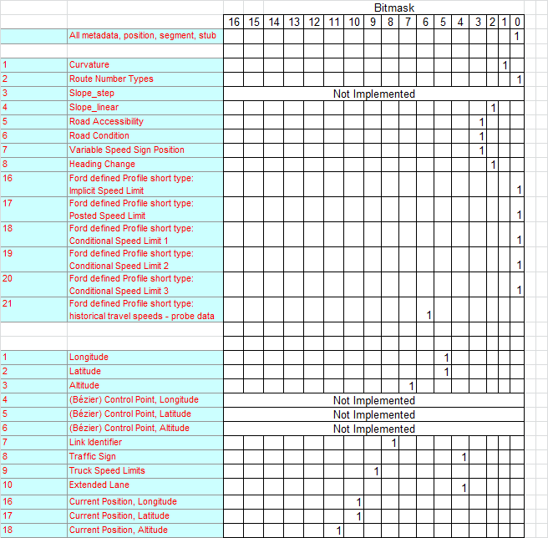

The specific data contained in each verbosity level are described in the referenced "ADAS Horizon Data Dictionary" document.

CAN layout, CAN IDs and multiplexing
A CAN messaging structure has already been identified by Ford and shall be used by this ADAS Horizon application.

The Motorola CAN message layout shall be used.

In accordance to the ADASIS v2 specification, section 11.6.2, a partially multiplexed CAN protocol using 2 CAN IDs shall be used. The first CAN ID shall be reserved for the POSITION messages, PROFILE LONG messages, and ADASIS Mini SEGMENT messages, whereas the second CAN ID is used for all other messages (multiplexed) sent in scope of the Main path with Stubs configuration. For more details see the ADASIS v2 specification, section 11.6.2. This is further defined in the referenced "Electronic Horizon Server SPSS" document.

CAN update rate
In accordance to the ADASIS protocol, data is generated and transmitted over the CAN bus in a non-periodic manner. This characteristic produces time windows of low bandwidth, as well as periods of high burst of CAN traffic. Irrespectively of the situation —even during these burst conditions—, the horizon provider must maintain a minimum inter-transmission time between CAN messages. This minimum time separation must be configurable, set to 20ms by default. Under no circumstance shall the horizon provider write messages with a separation interval below this value.

Required modification and/or additions shall be developed jointly between the supplier and Ford.

Position Message Updates
The Position message shall be updated and sent once per second.

Segment, Stub, Profile Message Updates
The Segment, Stub, and Profile messages shall be updated and sent when encountered within the MPP (event driven messaging).

MPP Change Data Repopulation Time
Upon an MPP change, The ADAS Horizon application shall repopulate up to 200m of the ADAS Horizon data of the new MPP, at the highest verbosity, within 2 seconds, and up to 2000m of the data of the new MPP within 10 seconds.

Calibration Parameters
The Electronic Horizon engine, as well as the ADASIS horizon provider must offer a mechanism for calibrating and tuning configuration mechanisms. This may be implemented via a configuration file residing on removable media or via network, but it shall not require firmware re-flashing or special hardware. The following table (Table 11-1) describes the minimum set of calibration variables.

Table 11-1. EH Calibration Parameters

Group | Variable Name | Purpose | Range | Resolution | Default Value
Horizon Engine | EhDepthMde_D_ParCal | Defines whether the horizon depth is based on distance or time | {distance, dynamic} | n/a | dynamic
Horizon Engine | EhDepthMax_L_ParCal | Defines the depth of the horizon in meters (only valid if EhDepthMde_D_ParCal is set to "distance") | 0-7500 meter | 1 m | 500
Horizon Engine | EhSpdDepth_Rt_ParCal | Defines the horizon length to be SpeedDepthRatio meters for every 1kph of the speed value rounded to the nearest 10kph (only valid if EhDepthMde_D_ParCal is set to "dynamic"). Also known as "Horizon Depth Scale Factor". | 3-50 meter/kph | 1 m/kph | 5
Horizon Engine | EhExpansMin_Pb_ParCal | Minimum probability that a node must have in order to get expanded, unless its distance is below minimum length (see below) | 0-1 | 0.1 | 0.1
Horizon Engine | EhDepthMin_L_ParCal | The horizon will be expanded at least to this minimum distance, regardless of the probability of the end node or speed (in the case of dynamic horizon) | 0-7500 meter | 1 m | 25
Horizon Engine | EhBwdDepthMin_L_ParCal | The horizon will be expanded to this distance behind the current position of the vehicle. Valid for "new" horizons (e.g. at vehicle start-up or change in MLP) | 0-500 meter | 1 m | 0
Static horizon predictor | EhTurnAngle_Wt_ParCal | Turn-angle weight factor (K_{ta}) | 0-1 | 0.01 | 0.1
Static horizon predictor | EhTurnTime_Wt_ParCal | Turn-time weight factor (K_{tt}) | 0-1 | 0.01 | 0.0
Static horizon predictor | EhFuncRdClDiff_Wt_ParCal | Functional road-class difference weight factor (K_{rcd}) | 0-1 | 0.01 | 0.1
Static horizon predictor | EhOutgoRdSig_Wt_ParCal | Outgoing Road Significance weight factor (K_{rs}) | 0-1 | 0.01 | 0.1
Static horizon predictor | EhPrefRteSeg_Wt_ParCal | Preferred Route Segment weight factor (K_{ps}) | 0-1 | 0.01 | 0.85
ADAS horizon provider | AhpVerbLvl_No_ParCal | Verbosity level | 1-6 | 1 | 1
ADAS horizon provider | AhpMinTx_T_ParCal | Minimum transmission period in milliseconds of ADASIS messages with same CAN id | 5-100 millisecond | 1 msec | 10
ADAS horizon provider | AhpMetaDataTx_T_ParCal | MetaData max transmission period in seconds. Can be sent at different update rate than other messages. | 0-10 sec | 0.1 sec | 5.0
ADAS horizon provider | AhpMsgRepDist_L_ParCal | Distance at which a SEGMENT or PROFILE message is resent if there is no change in the map data (data same as in the previous message but for the new offset). | 0-7500 meter | 1 | 1000
ADAS horizon provider | AhpAminiTx_T_ParCal | ADASIS mini SEGMENT message transmission period in seconds. Only valid for ADASIS Mini. | 0-5 sec | 0.1 sec | 1.0
ADAS horizon provider | AhpLatLongTx_D_ParCal | Defines whether or not to transmit the "Profile Long" Latitude and Longitude messages | {on, off} | n/a | off

HMI
Electronic horizon is a technology that works as a virtual sensor, serving many applications simultaneously. Because of this, electronic horizon does not interact with the driver's directly, but rather through the specific application being supported. This makes HMI concepts not applicable to EH.

